**DATA VISUALIZATION**

The data visualization tool that we are planning to use for project is Tableau. In our project we are comparing player clusters with their VORP. Also look at if they change player type do they still regress.

Value over Replacement Player (available since the 1973-74 season in the NBA); a box score estimate of the points per 100 TEAM possessions that a player contributed above a replacement-level (-2.0) player, translated to an average team and prorated to an 82-game season.

A dashboard will display correlation between player regression and different archetypes along with their VORP score.

Below are few sample charts that can be used for correlation analysis.

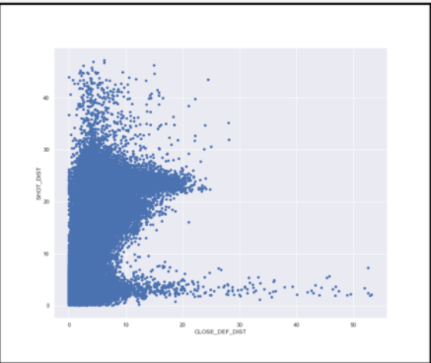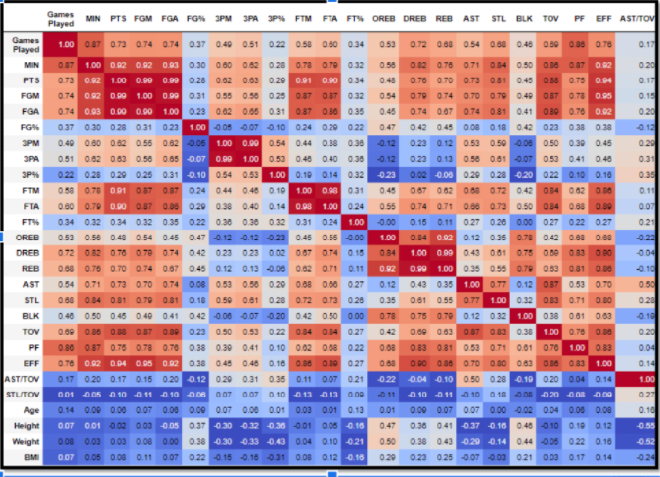

We can explore different tools and charts for data visualization as we move along the project depending upon the changing business requirements and analysis subsequently.